Generative AI

Type of Data

📊 Structured Data (in Generative AI)
Definition:
Data that is organized in a fixed format (rows & columns) and easy for computers to search and analyze.
✅ Highly organized
✅ Stored in databases or spreadsheets
✅ Same structure for every record
Examples
- SQL database tables
- Excel sheets
- Customer records
- Banking transactions

🧠 Unstructured Data (in Generative AI)
Definition:
Data that does not follow a fixed format and is harder to organize automatically.
✅ No predefined schema
✅ Human-readable content
✅ Majority of real-world data
Examples
- Emails
- PDFs
- Images
- Audio recordings
- Videos
- Chat messages
- Social media posts
Example
Customer review:
"The product quality is amazing but delivery was late."
✅ Simple Rule to Remember
- Rows & Columns → Structured Data
- Text, Image, Video → Unstructured Data

✅ Type of machine learning model

✅ 1. Supervised Learning
Definition:
Model learns using labeled data (input + correct output already given).
Common Uses
- Spam detection
- House price prediction
- Image classification
- Fraud detection

✅ 2. Unsupervised Learning
Definition:
Model learns from unlabeled data (no correct answers).
👉 Model finds hidden patterns itself.
Example
Customer data without categories → model groups similar customers.
Common Uses
- Customer segmentation
- Pattern discovery
- Recommendation systems
- Data compression

✅ 3. Reinforcement Learning (RL)
Definition:
Model learns by trial and error(or by feedback) using rewards and penalties.
👉 Like learning by experience.
Concept
- Agent takes action
- Gets reward or punishment
- Improves strategy over time
Common Uses
- Self-driving cars
- Game playing
- Robotics
- Recommendation optimization

🧠 Generative AI models

1) Large Language Models (LLM)
Definition:
LLMs are AI models trained on massive text data to understand and generate human language.
👉 Based on Transformer architecture.
What they do
- Text generation
- Chatbots
- Coding assistance
- Translation
- Summarization
Examples
- GPT models
- LLaMA
- Claude
- Gemini
Simple Idea
Predict the next word/token again and again.
2) Diffusion Models
Definition:
Models that generate images by starting with random noise and gradually removing noise.
👉 Learn how to clean noise → create image.
How it works
- Add noise to image during training
- Model learns to reverse noise
- Start from noise → generate new image
Used For
- Image generation
- Text-to-image AI
- Video generation
Examples
- Stable Diffusion
- DALL·E
- Midjourney (conceptually)
✅ Prompt: "Astronaut riding horse" → Generated image
3) Generative Adversarial Networks (GAN)
Definition:
Two neural networks competing with each other.
👉 Generator vs Discriminator
Components
- Generator → creates fake data
- Discriminator → detects fake vs real
They improve together like a game.
Used For
- Deepfakes
- Face generation
- Image enhancement
- Style transfer
✅ Generator tries to fool the discriminator.
4) Neural Radiance Fields (NeRF)

Definition:
AI technique to create 3D scenes from multiple 2D images.
👉 Learns how light behaves in space.
Idea
Many photos → AI builds realistic 3D environment.
Used For
- 3D reconstruction
- Virtual reality
- Gaming
- Digital twins
- Movie VFX
✅ Example: Take photos around a room → generate navigable 3D scene.

5) Hybrid Models

Definition:
Models that combine multiple AI techniques together.
👉 Mix of LLM + Vision + Diffusion + RL etc.
Examples
- Text + Image + Audio models
- Multimodal AI systems
Used For
- ChatGPT vision
- Video generation
- AI assistants
- Robotics
✅ Example:
Text prompt → generate image + explanation + voice response.

🧠 Main Features of LLM (Large Language Models)

✅ 1. Large Scale (Huge Parameters)
LLMs contain billions or trillions of parameters, making them much larger than traditional ML models.
👉 More parameters = better understanding of language patterns.
Example:
GPT models trained on massive internet text data.

✅ 2. General Purpose Model
LLMs are multi-talented language systems.
They can perform many tasks without building separate models:
- Question answering
- Coding assistance
- Translation
- Summarization
- Chatbots
- Content generation
👉 One model → Many tasks.

✅ 3. Pre-training and Fine-tuning
Pre-training
- Model learns general language knowledge from large datasets.
Fine-tuning
- Model is customized for a specific task or domain.
Example
- Pretrained on internet text
- Fine-tuned for medical chatbot or customer support AI

✅ Few-Shot Learning
Model learns a task using very few examples.
Example Prompt
Translate English to French:
Hello → Bonjour
Good Morning → Bonjour
Thank you →
Model understands pattern with only few samples.
👉 Minimal training data required.

✅ Zero-Shot Learning
Model performs a task without explicit training examples.
Example Prompt
Classify sentiment:
"I love this phone."
Even without training examples, model understands sentiment.
👉 Uses knowledge learned during pretraining.

🧠 ANN, CNN, RNN and Transformers (Simple Explanation)

✅ 1. Artificial Neural Network (ANN)
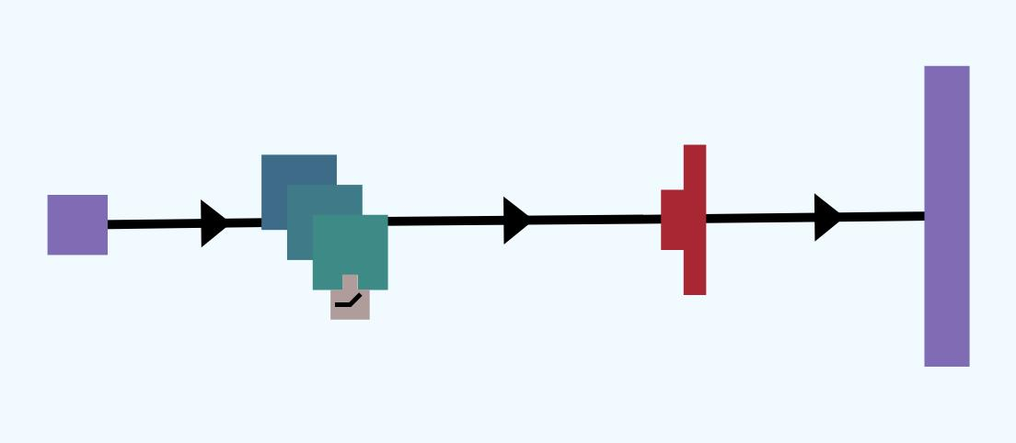
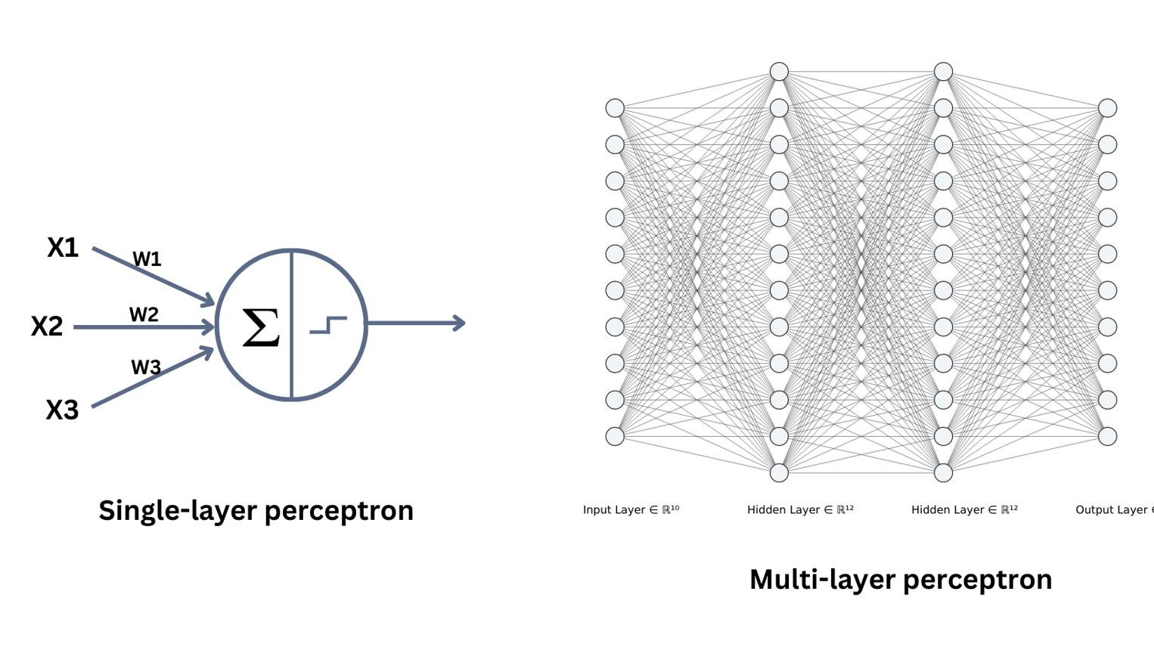
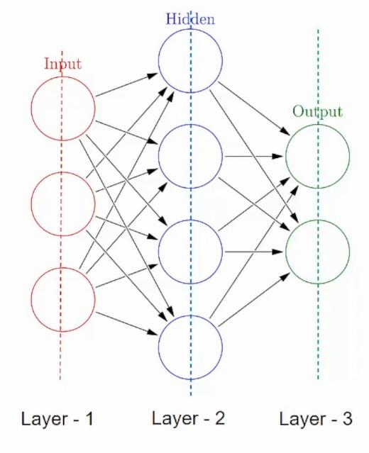
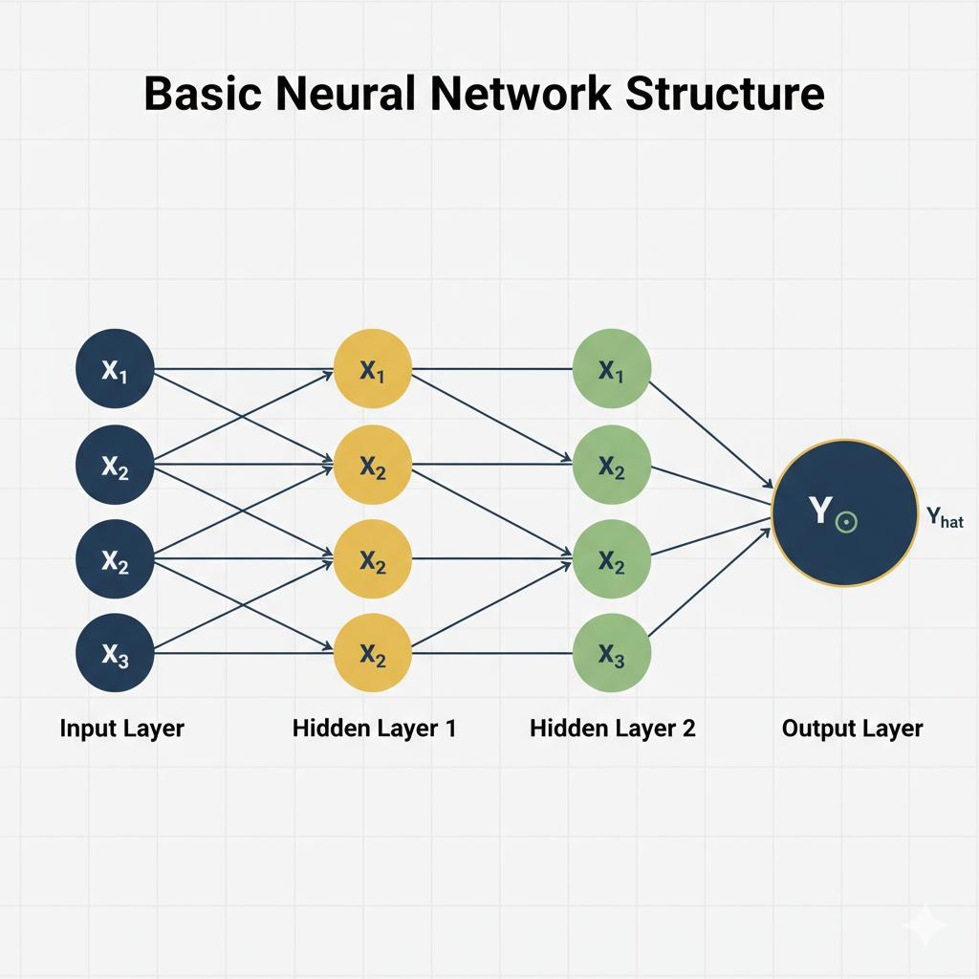

What is ANN?
ANN is the basic neural network inspired by the human brain.
👉 Data flows:
Input Layer → Hidden Layers → Output Layer

Problem it Solves
- Structured/tabular data prediction
- Classification & regression
Examples
- Loan prediction
- Sales prediction
- Fraud detection

Drawbacks ❌
- Cannot understand images well
- Cannot handle sequence data (text/speech)
- Loses spatial & temporal information

✅ 2. Convolutional Neural Network (CNN)
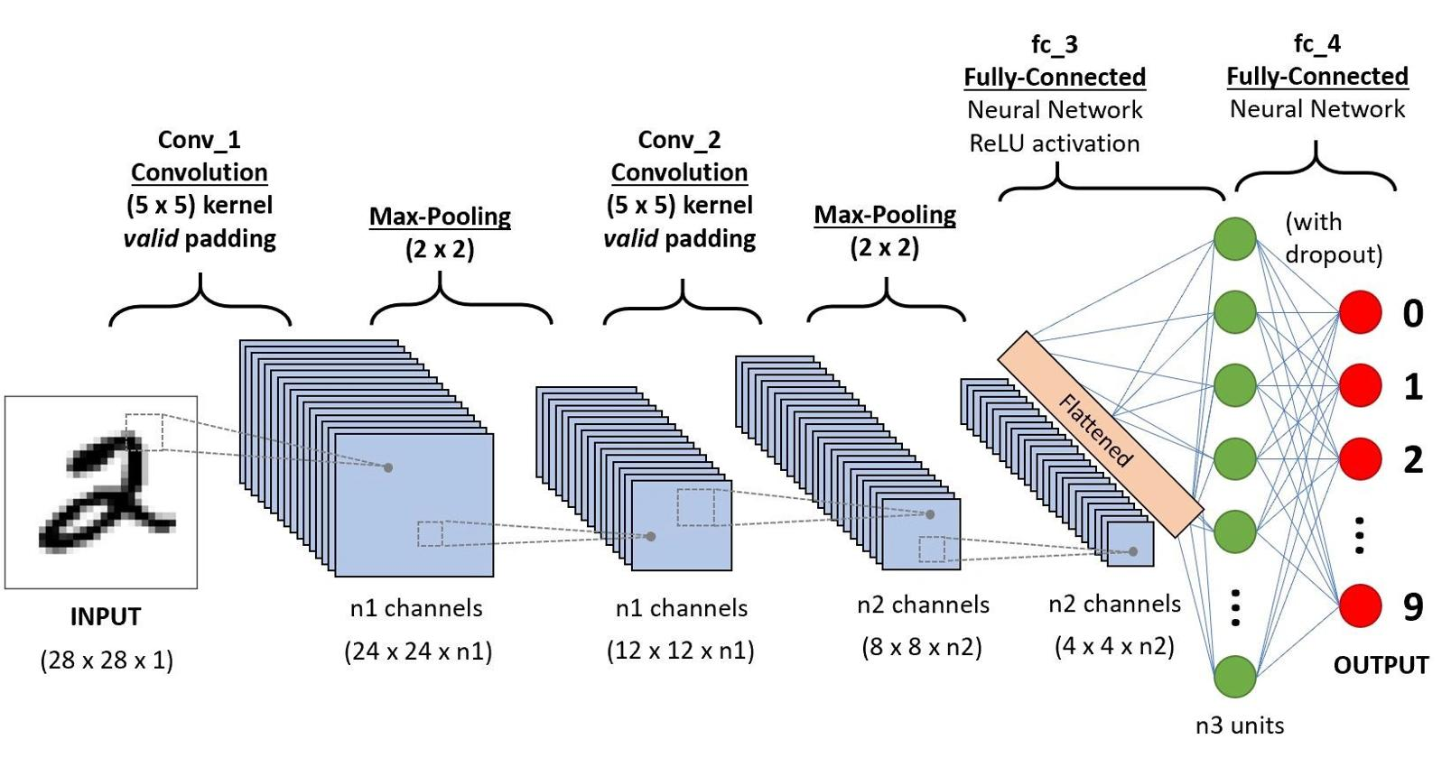
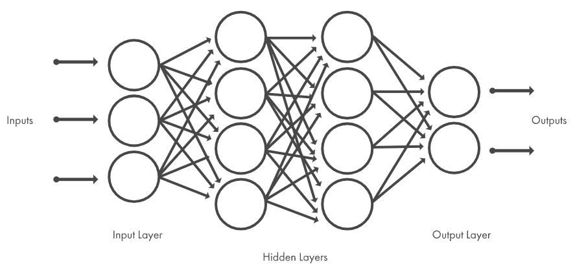
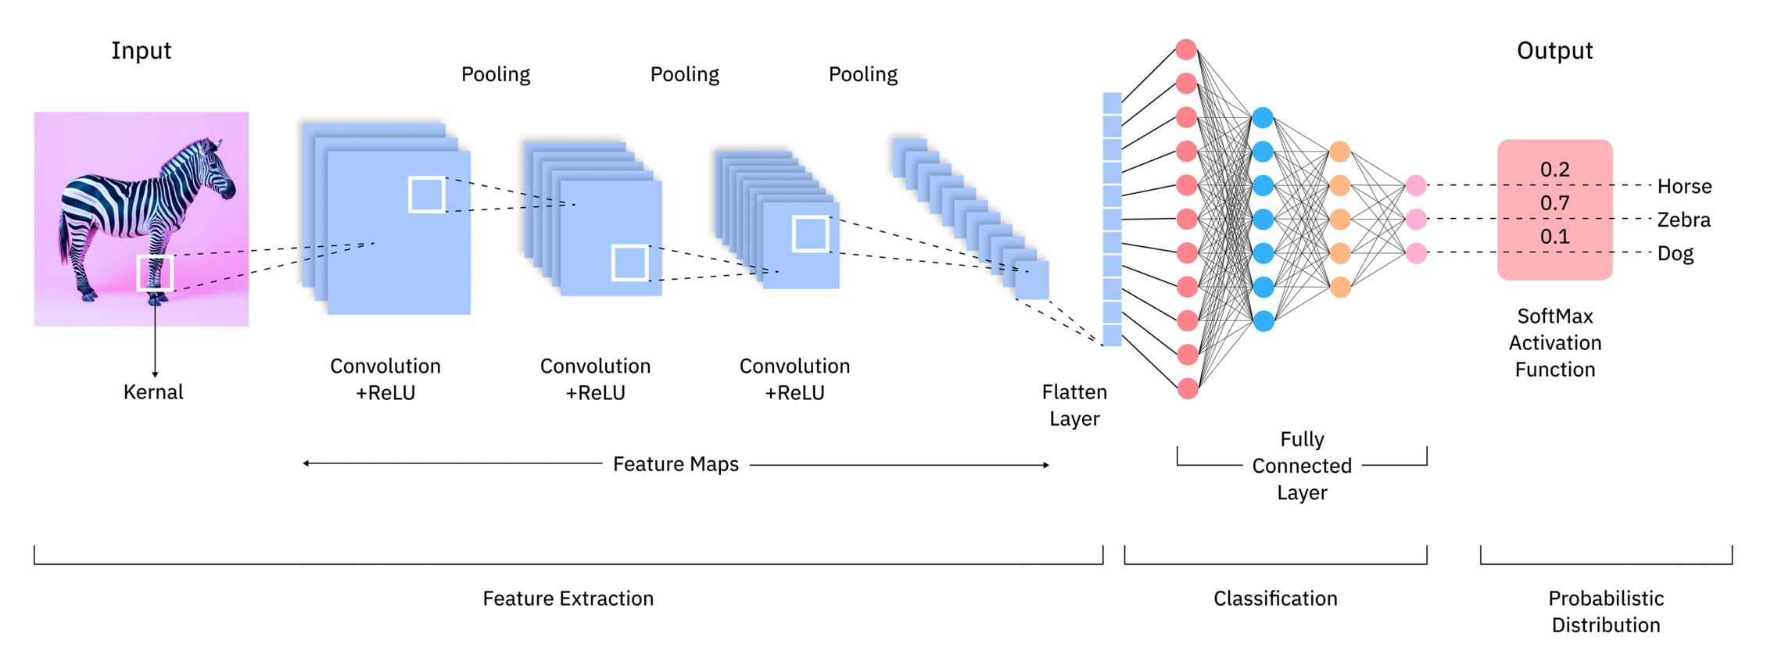
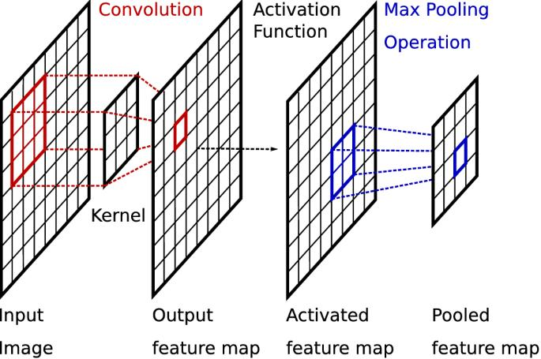
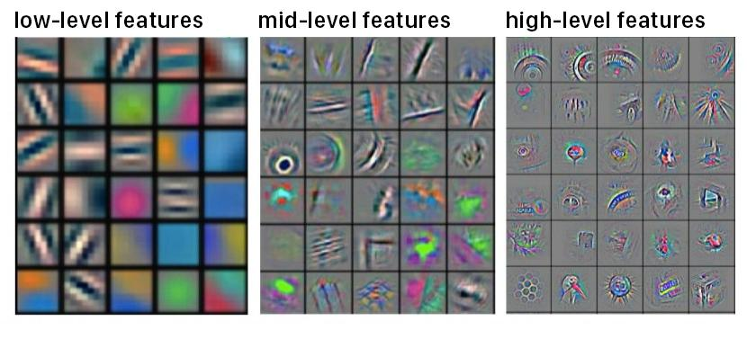
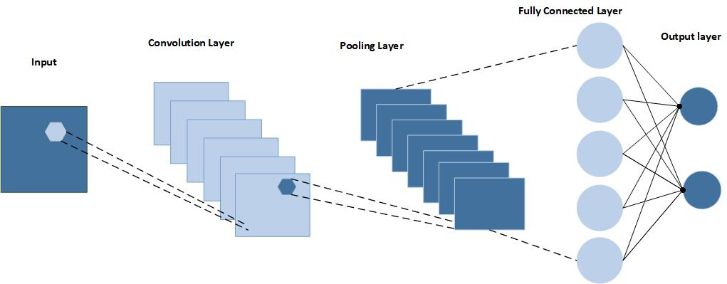

What is CNN?
CNN is designed for image and visual data.
👉 Uses convolution filters to detect:
- edges
- shapes
- textures
- objects

Problem it Solves
- Image recognition
- Face detection
- Medical imaging
- Object detection

Drawbacks ❌
- Not good for long text sequences
- Needs large labeled datasets
- Limited long-range understanding

✅ 3. Recurrent Neural Network (RNN)
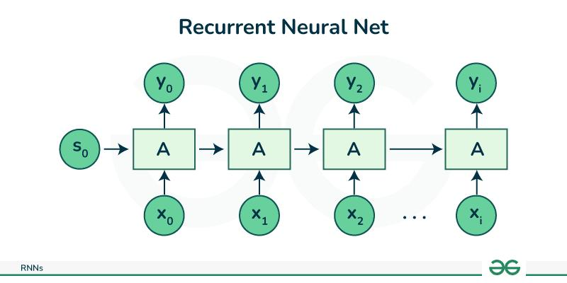
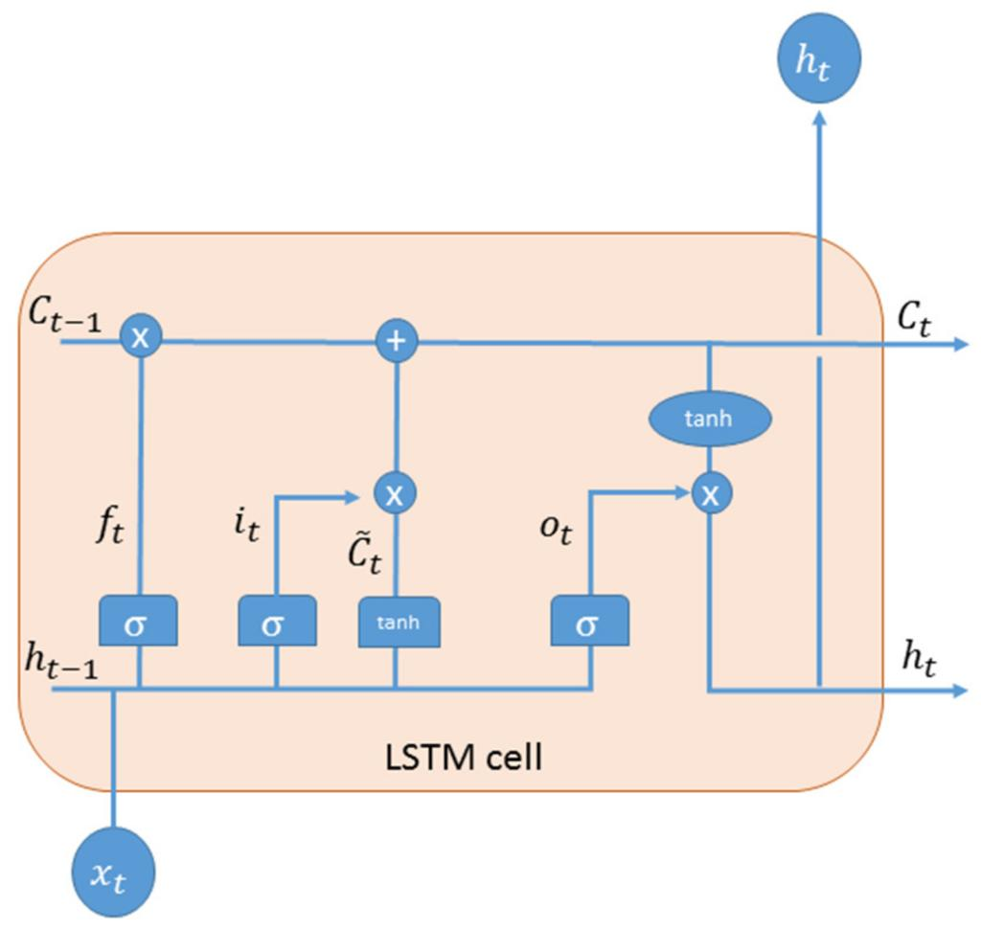
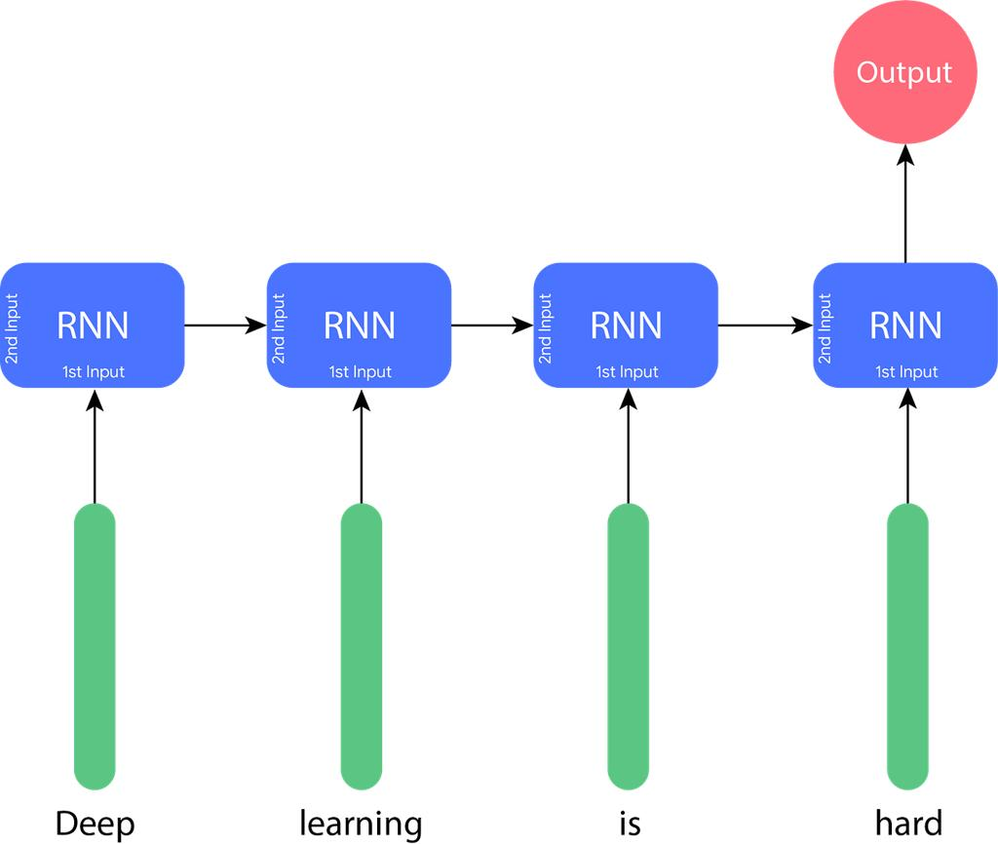
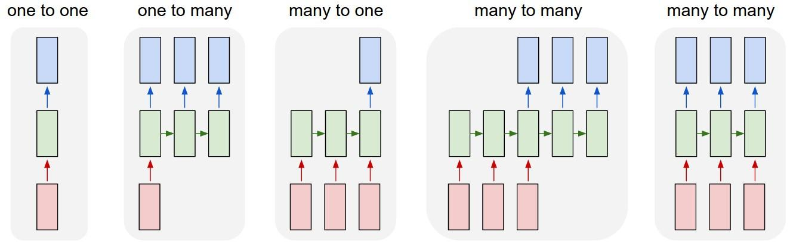
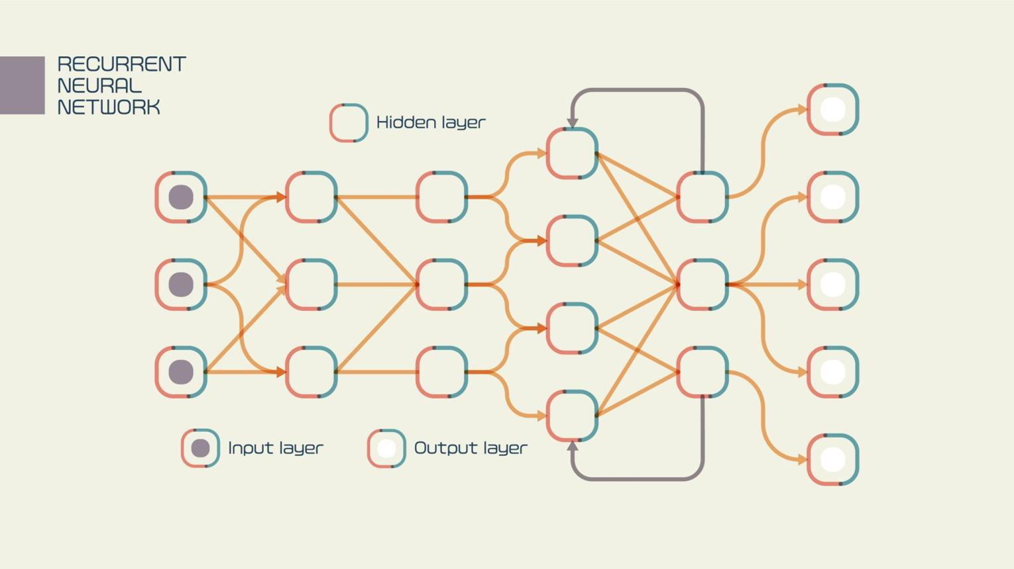

What is RNN?
RNN processes sequential data by remembering previous inputs.
👉 Has memory from past steps.

Problem it Solves
- Language modeling
- Speech recognition
- Time-series prediction
- Translation (old NLP systems)

Drawbacks ❌
- Vanishing gradient problem
- Cannot remember long context
- Training is slow (sequential processing)
- Hard to scale

🚀 Why Transformers Were Needed
RNNs failed at long-context understanding.
Example:
"The book that I bought yesterday from the shop near my office was amazing."
RNN struggles to connect book → amazing when sentence is long.
👉 We needed a model that:
- Understands long relationships
- Trains faster
- Works in parallel

✅ 4. Transformer Model
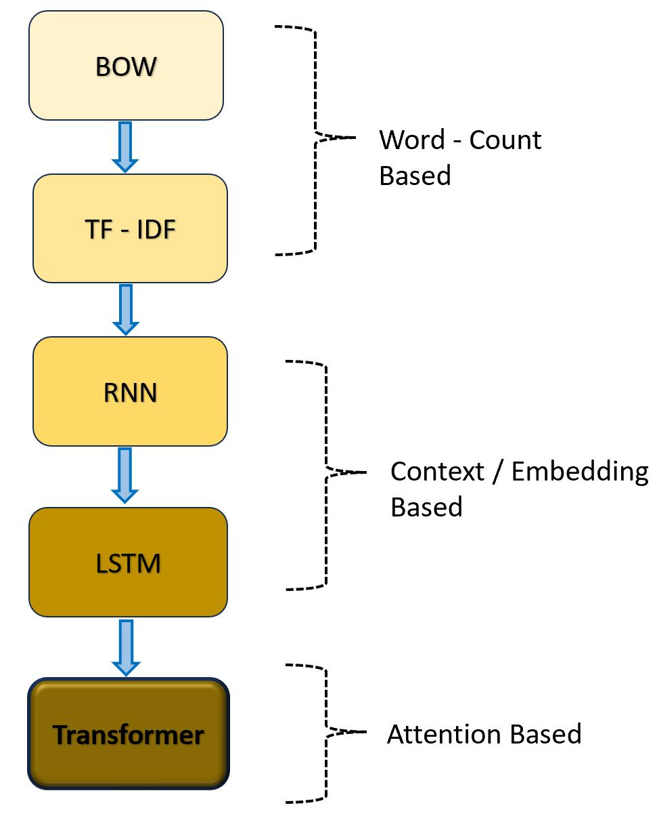
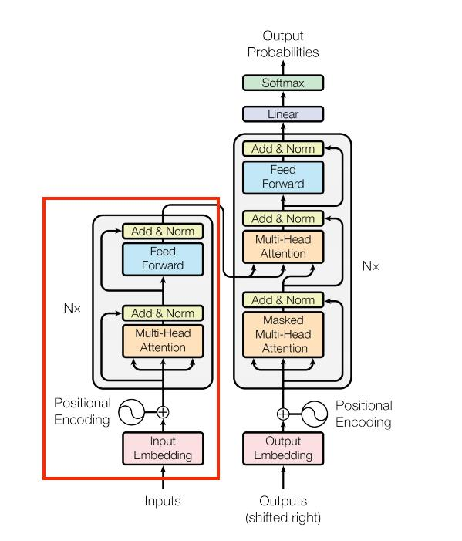
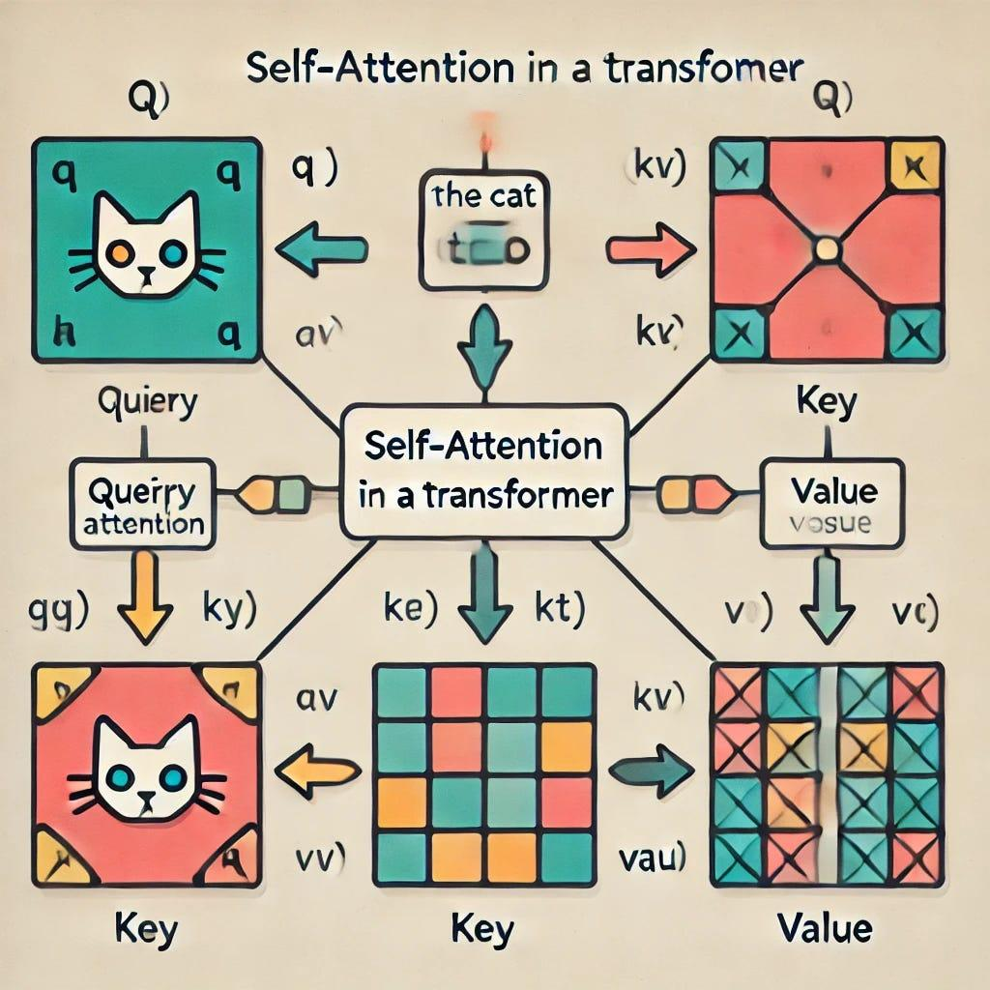
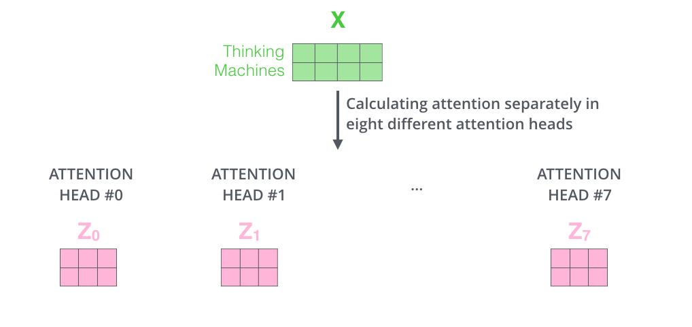

What Problem Transformers Solve
✅ Long-context understanding
✅ Parallel training
✅ Better language understanding
✅ Scalable to billions of parameters

How Transformer Works (Simple)
Core idea 👉 Self-Attention
Instead of reading word-by-word like RNN:
👉 Transformer looks at all words at once.
Steps
- Convert words → embeddings
- Apply Self-Attention
- Calculate importance between words
- Process in parallel layers
- Generate output
Example:
Model learns relationship between:
- subject
- verb
- context
- meaning

🧩 What are Tokens in LLMs?
Tokens are the small pieces into which text is broken before an AI model understands it.
👉 LLMs do NOT read sentences directly.
They first convert text → tokens → numbers → embeddings.

✅ Step-by-Step Example
Sentence:
I love natural language processing

Step 1 — Tokenization
The sentence is split into tokens:
["I", "love", "natural", "language", "processing"]
A token can be:
- a word
- a part of a word (subword)
- a single character
- punctuation or symbols

✅ Why Tokens Are Needed
Computers cannot understand text directly.
So the pipeline is:
Text → Tokens → Token IDs → Embeddings → Model Understanding
Example:
"love" → Token ID 4587 → Vector (numbers)
LLM understands numbers, not words.
👉 Token IDs are NOT random.
They come from a predefined vocabulary created during tokenizer training.

✅ Types of Tokens

1. Word Tokens
Hello world → ["Hello", "world"]

2. Subword Tokens (Most Common in LLMs)
Used for unknown or rare words.
unbelievable → ["un", "believ", "able"]
✅ Reduces vocabulary size
✅ Handles new words

3. Character Tokens
AI → ["A", "I"]
Used rarely in modern LLMs.

✅ Important Concept — Token ≠ Word
Approximate rule:
👉 1 token ≈ 3–4 English characters
Example:
100 words ≈ 130–150 tokens
That’s why LLM limits are measured in tokens, not words.

✅ Why Tokenization Is Critical
Tokens determine:
- Context length (how much AI remembers)
- Cost of API usage
- Model performance
- Speed of generation

🧠 What is an Embedding Model?
An Embedding Model converts text, image, audio, or data into numerical vectors (embeddings) so that AI can understand meaning and similarity.
👉 Simply:
Human data → Mathematical representation → AI understanding

🔢 How an Embedding Model Works
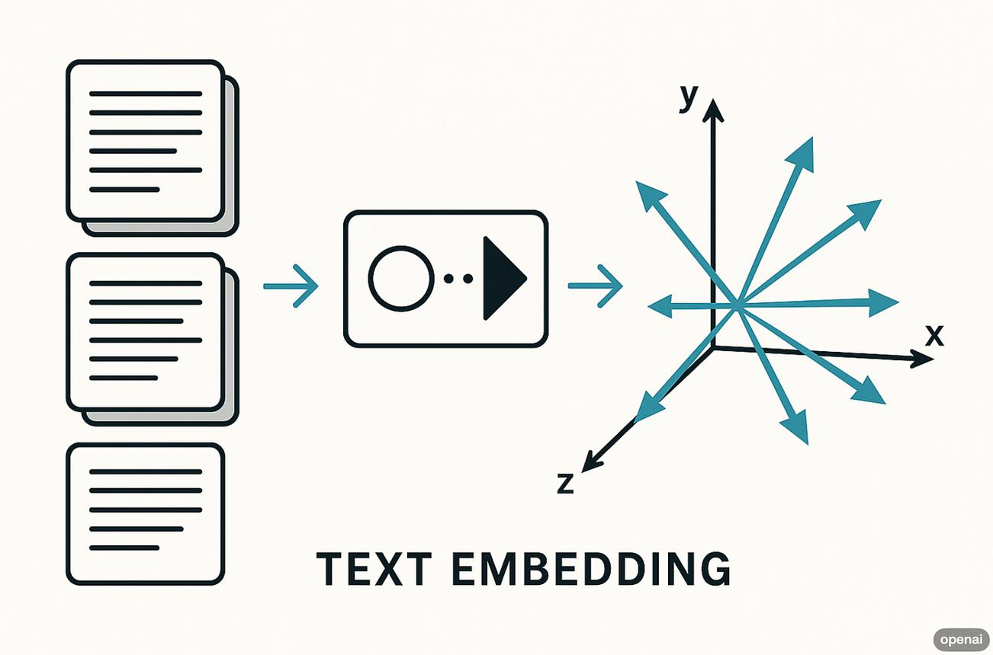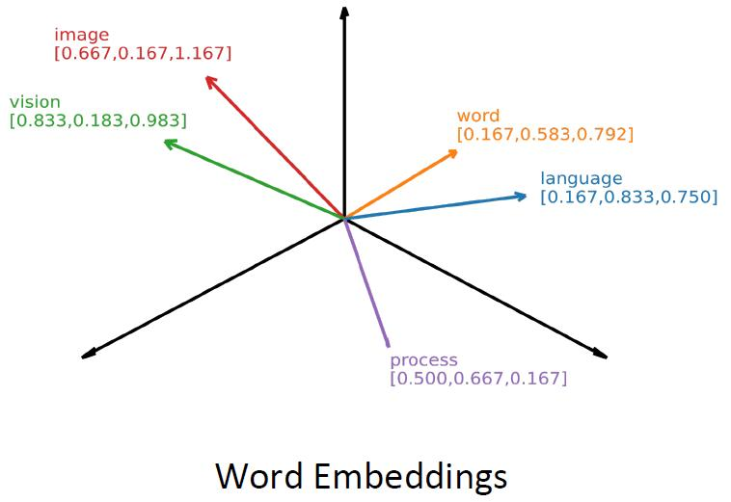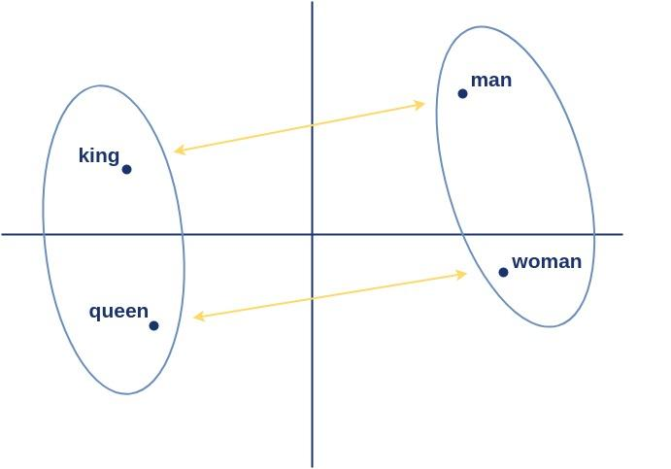
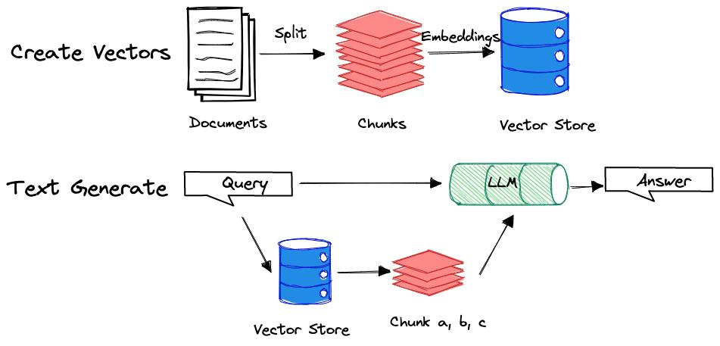

Step-by-step
- Input text comes to embedding model
- Text is tokenized
- Model converts tokens into vectors (numbers)
- Similar meanings get similar vectors
Example:
"dog" → [0.21, -0.44, 0.91, ...]
"puppy" → [0.23, -0.40, 0.89, ...]
👉 Vectors are close → meanings are similar.

🎯 What Embedding Models Do
Embedding models help AI to:
✅ Semantic Search (search by meaning)
✅ Recommendation systems
✅ RAG (Retrieval-Augmented Generation)
✅ Chatbots memory search
✅ Document similarity matching
✅ Clustering & classification
Example:
- Search "cheap phone"
- System also finds "budget smartphone"
Because embeddings capture meaning, not exact words.

🧠 Transformer Architecture (Encoder–Decoder)
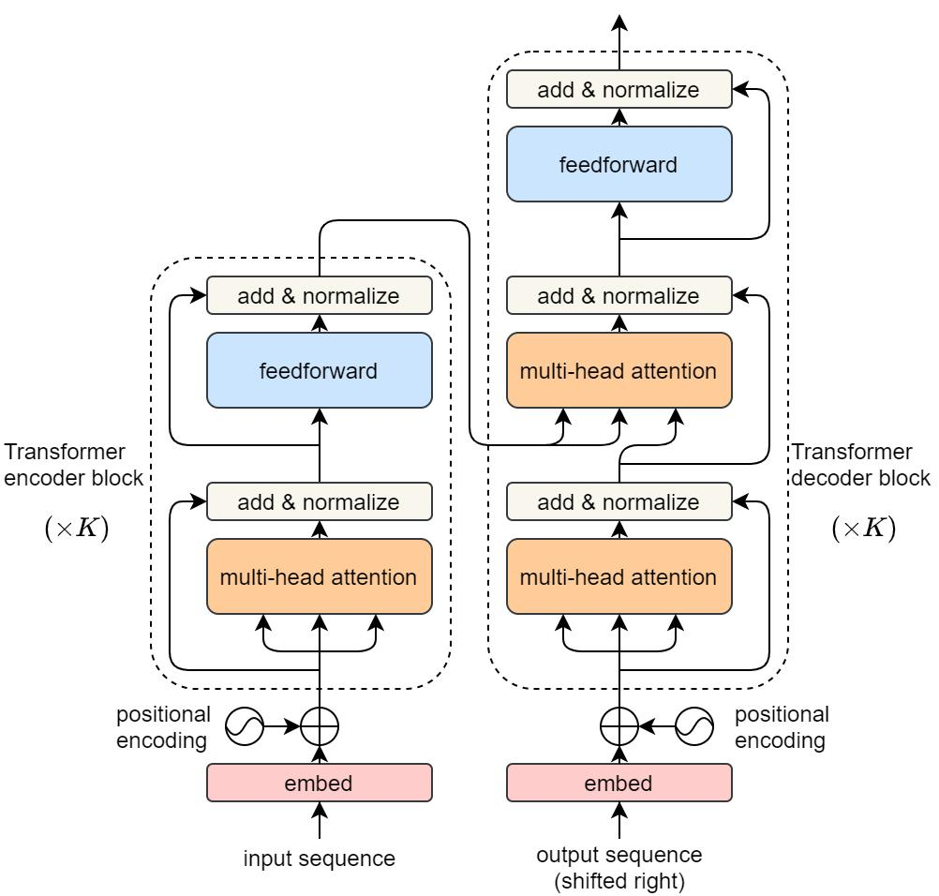
The diagram has two main parts:
👉 Left = Encoder
👉 Right = Decoder
(Modern GPT models mostly use only the Decoder part.)

✅ 1. Input Embedding

Example Input
"I love AI"

What happens?
- Sentence → Tokens
- Tokens → Token IDs
- Token IDs → Embedding vectors
"I" → vector1
"love" → vector2
"AI" → vector3
Now words become numbers with meaning.

✅ 2. Positional Encoding
Problem:
👉 Transformer reads words all at once.
It doesn't know order.
Example:
Dog bites man
Man bites dog
Same words — different meaning.

Solution → Positional Encoding
Adds position information:
I (position 1)
love (position 2)
AI (position 3)
So model understands sequence order.

✅ 3. Encoder Block (Left Side)
Repeated N times (Nx).
Each encoder layer contains:

🔹 Multi-Head Self Attention

Core Idea
Every word looks at every other word.
Example:
"I love AI"
Attention relationships:
Word | Pays Attention To
I | love
love | I + AI
AI | love
Model learns context automatically.

Why Multi-Head?
Multiple attentions learn different relations:
- grammar
- meaning
- subject-object relation
- sentiment
👉 Many brains thinking together.

🔹 Add & Norm (Residual Connection)
Purpose:
- Prevent information loss
- Stabilize training
Formula idea:
Output = Layer(x) + x
Keeps original information.

🔹 Feed Forward Network
Small neural network applied to each token independently.
It:
- refines meaning
- increases representation power

Encoder Output:
👉 Context-aware embeddings.

✅ 4. Decoder Block (Right Side)
Decoder generates new text.
Example task:
Input: Translate "I love AI"
Output: "Je aime IA"

🔹 Masked Multi-Head Attention
Very important.
When predicting next word:
Model cannot see future words.
Example:
"I love ___"
Model only sees:
I love
NOT the next word.
This prevents cheating during training.

🔹 Encoder–Decoder Attention
Decoder looks at encoder output.
Example:
- Encoder understands input sentence
- Decoder focuses on relevant words while generating output

🔹 Feed Forward + Add & Norm
Same processing as encoder.
Repeated multiple times.

✅ 5. Linear Layer
Converts decoder output vector → vocabulary size.
Example:
Vector → 50,000 possible words

✅ 6. Softmax Layer (Prediction)
Softmax converts scores into probabilities.
Example:
Word | Probability
AI | 0.72
coding | 0.15
pizza | 0.01
Model chooses highest probability.
👉 Generates next token.

🔥 Text Generation Example (Full Flow)
Input:
"I love"
Flow:
Embedding
↓
Self Attention
↓
Decoder predicts next token
↓
Softmax
↓
"AI"
Then repeats:
"I love AI because..."
Token by token generation.

